**ProjectTitle**: Signs with smart connectivity for better road safety

**TeamID**: PNT2022TMID30265

**ProjectDesignPhase–I:** SolutionFitTemplate

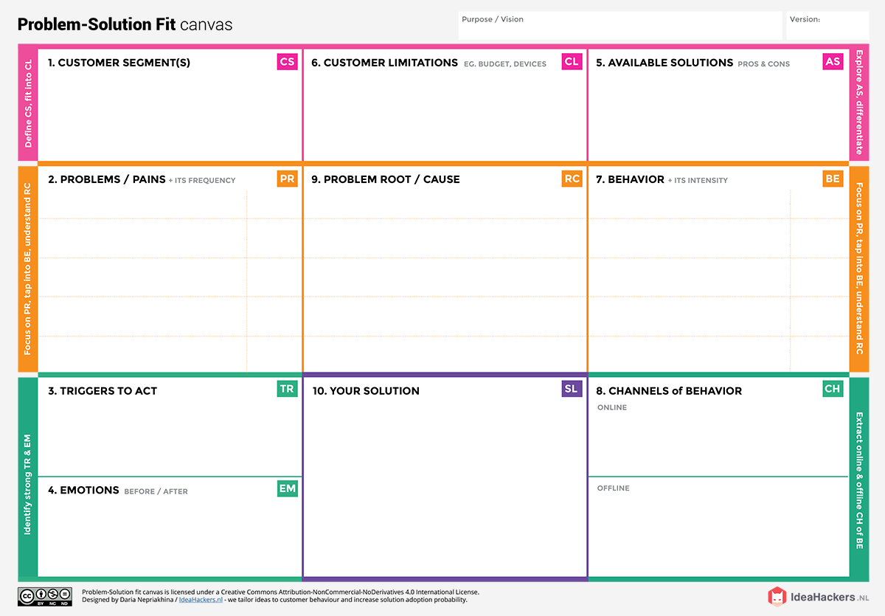

High quality safety data should be used to determine the nature of the road safety ,used to identify safety on a large or a small scale,such as roadway's, traffic volume, driver history.

The customer feels insecure, panic, afraid when they face a problem, after that they feel confident and safety.

Data setup

To improve safety and reduce road crash casualties.

Budget and Available device.

Roads are used for general transport purposes, but they can be deadly as well. More than half of all road traffic deaths and injuries involve vulnerable road users, such as pedestrians, cyclists and motorcyclists and their passengers.

Data will be the performance measures used to identify the road safety emphasis areas and serious injury crashes as performance measures for road safety.

Find the data of the public and take measures accordingly.

Create a user crash data and other safety data to identify road safety problems or problem locations.

It will develop potential strategies to address the identified safety problems. These strategies might also be referred to as countermeasures or treatments.

Install the data and operate the system software.